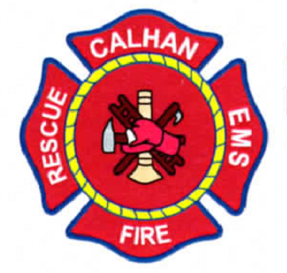

10/1/2023

The Calhan Fire Protection District is looking to fill 1 opening for Paramedic/Firefighter starting late October/early November 2023. This is a 48/96 shift schedule.

All applicants shall meet the following requirements:

* Be a US Citizen and/or be able to prove legal residency in the United States.
* High school diploma or equivalent (GED)
* Currently hold a state of Colorado Paramedic certification in good standing.
* Current BLS and ACLS certification. PALS certification within 90 days of hire.
* Current Colorado driver’s license or have the ability to obtain a Colorado driver’s license upon hire.
* Continuously maintain all required certifications
* Clean driving record
* Ability to pass a drug screen panel and comprehensive background investigation.
* Lift and move 200lbs
* Ability to lift, drag, hoist, and carry different types of equipment and other objects.
* May work indoors or outdoors with exposure to weather.
* Successfully complete medical director’s annual testing.
* Able to work cooperatively with volunteers and paid staff.

Responsibilities:

* Assess patients and evaluate best course of action as to treatment of patients, including transport destination.
* Follow current medical guidelines.
* Transport patients to the hospital.
* Understand and operate all CFPD vehicles.
* Keep vehicles stocked and ready for the next call/shift.
* Understand the rules and use of the 800mhz county radio system.
* All paramedics will be required to perform firefighting tasks, as firefighting/fire prevention is the primary function of a fire district.
* Fire experience preferred; fire certifications are not required.
* Ability to work past scheduled shift with little or no notice.
* Complete all necessary paperwork, including medical reports before end of shift.

Benefits:

* Pay 60,000-65,000 a year DOE
* FPPA retirement
* Medical insurance
* Paid vacation

If you feel you are interested in working with us, please contact us with a resume. If you have any questions, feel free to contact us at calhanfire@qwestoffice.net

Email resume to: [cfpdchief@calhanfire.org](mailto:cfpdchief@calhanfire.org)

**Board of Directors**

**Chairman**

Albert Kobilan

**Board Member**

Dwayne Jagodenski

**Board Member**

Rod Riggs

**Board Member**

Ken Harris

**Board Member**

Ed Doven

**Calhan Fire Department**

**725 4th Street, Calhan, CO 80808**

**Non-Emergency: 1-719-347-3057 Fax: 1-719-347-3191**

**Emergency: 911**

Web Site [www.calhanfire.org](http://www.calhanfire.org) E-mail calhanfire@qwestoffice.net